**Unit 4**

**Copyright**

Copyright is a right given by the law to creators of literary, dramatic, musical and artistic works and producers of cinematograph films and sound recordings. In fact, it is a bundle of rights including, inter alia, rights of reproduction, communication to the public, adaptation, and translation of the work. There could be slight variations in the composition of the rights depending on the work. Copyright ensures certain minimum safeguards of the rights of authors over their creations, thereby protecting and rewarding creativity. Creativity being the keystone of progress, no civilized society can afford to ignore the basic requirement of encouraging the same. The economic and social development of a society is dependent on creativity. The protection provided by copyright to the efforts of writers, artists, designers, dramatists, musicians, architects and producers of sound recordings, cinematograph films and computer software, creates an atmosphere conducive to creativity, which induces them to create more and motivates others to create.

Benefits of getting copyright registered

* Copyright registration **creates a public record**. It tells the world that your work is protected by copyright and also enables a person who wants to licence your work to find you.
* It enables you to **file a lawsuit and take legal action** against someone who infringes your copyright, say by selling copies of your work without your permission.
* It **provides you with economic benefits** by entitling you to use your work in various ways like making copies, performing in public, broadcasting your work etc, and availing appropriate reward for it. Thus, it provides you with a reward for your creativity.
* It allows you to **sell or pass the rights**of your work.
* It allows you to get**legal evidence of your ownership**. So if someone prevents you from using your work, you can just use your copyright to prove that it’s your work and you have a right to use it.
* It allows you to**change the form of your work**. For example, it allows you to make a sequel or revise or update the work.

**Copyright Law**

he Copyright Act, 1957, governs the law pertaining to copyright in India. The major goals of this copyright law are twofold: first, to guarantee authors, musicians, painters, designers, and other creative individuals the right to their creative interpretation; and second, to enable others to openly develop upon the concepts and knowledge made available by a work. India’s history with copyright laws dates back to the British Empire’s colonial rule. A law called the Indian Copyright Act, 1957, was passed; it went into effect in January 1958 and has since undergone five revisions, in 1983, 1984, 1992, 1994, and 1999. The Copyright Act of 1957 was India’s first copyright law following independence, and six amendments have been made since then. The Copyright (Amendment) Act 2012, which was passed in 2012, was the most recent amendment. The concept of copyright in India is governed by the Indian Copyright Act, 1957, as modified from time to time, and the Indian Copyright Rules, 1958 (Rules).

Copyright Law safeguards manifestations of ideas. Literary works, theatrical works, musical works, creative works, cinematographic films, and sound recordings all have copyright protection under Section 13 of the Copyright Act of 1957. For instance, the Act protects literary works such as books and computer programs.

The term “copyright” refers to a collection of exclusive rights that Section 14 of the Act grants to the owner of the copyright. Only the copyright owner or another person who has permission to do so from the copyright owner may exercise these rights.

In India, the earliest law of copyright was enacted by the British during the realm of East India Company that is the Indian Copyright Act, 1847 which was passed for the enforcement of rules of English copyright in India. After it, by Copyright Act 1911,  this law was repealed, replaced and applied to all British colonies including India. Further, it was again modified in 1914 by the Indian Copyright Act, 1914, which remained applicable in India until replaced by the Copyright Act, 1957 by the parliament of sovereign India.

The Copyright Act of 1957 outlines the range of these permissible uses. To establish harmony between the rights of the copyright owner and the welfare of people to the greatest possible degree in the interest of society, measures relating to free use are included in the Act. The Madras High Court held that *“copyright law is to preserve the fruits of a man’s effort, labour, talent, or test from annexation by other persons”*

# Salient features of the Copyright Act, 1957

The salient features of the Copyright Act, 1957 are herein mentioned below:

## Scope of rights conferred to the author

Literary works, musical works, theatrical works, creative works, sound recordings, and cinematographic films are all protected by copyright under Section 13 of the Copyright Act of 1957. Literary works, for instance, books, manuscripts, poetry, and these are safeguarded by the Act. Original literary, dramatic, musical, and artistic works as well as cinematographic and sound recordings are shielded from illegal access under the Copyright Act of 1957. In contrast to patents, copyright safeguards expressions rather than ideas.

## Provisions to assert the ownership

The original owner of the copyright is the creator of the work itself, as stated in Section 17 of the Copyrights Act of 1957. The one exception to this rule is when an employee creates work while performing duties as part of their employment, in which case the employer assumes ownership of the copyright.

## Civil and criminal remedies

Section 55 of the Copyright Act of 1957 addresses civil remedies for copyright infringement. These civil remedies encompass restitution, injunctions, account interpretation, deletion and surrender of copies made infringing, as well as conversion damages. Section 63 of the Copyright Act of 1957 specifies criminal penalties for copyright infringement. These criminal penalties can take the form of jail time, fines, searches, the seizure of contraband, etc. The maximum sentence for imprisonment is 3 years, but it cannot be less than 6, and the maximum fine is between 50,000 and 2,00,000 rupees.

## Establishment of copyright boards and offices

The Copyright Act of 1957 also makes provisions for the establishment of a copyright board to assist in resolving copyright-related issues and a copyright office, which comes under the jurisdiction of the Registrar of the Copyright, for the registration of books and other “works” of art. The establishment of an office to be known as the Copyright Office for Act purposes is provided for under Section 9 of the Copyright Act, 1957. The Copyright Board was established under Section 11 of the Copyright Act of 1957.

# Important sections of the Copyright Act, 1957

The following are the important sections of the Copyright Act of 1957:

* Section 2 deals with various definitions of the work which can be covered under the definition of copyright. For example, Section 2(o) deals with literary works, Section 2(h) includes all dramatic works under the definition of copyright protection, and Section (p) deals with musical and graphical works.
* Section 13 of the Copyright Act, 1957, is the most requisite Section as it deals with the subject matter of copyright protection. According to Section 13(1), all of India is under the purview of the Copyright, and the following classifications of works are protected by the Copyright:

1. Original artistic, musical, dramatic, and literary works
2. Sound recording
3. Cinematograph films

The published and unpublished works of architecture are discussed in Section 13(2). If the work is published, it must be published in India. If the work is published outside of India, the author must be an Indian citizen at the time of publication or at the time of his death. Except for works of architecture, the authors of unpublished works must be Indian citizens or have a place of residence in India. When it comes to architectural works, only the work itself must be from India and not the architect, because architectural works can also be done in written form. The copyright in an architectural work shall only apply to the creative character and design and shall not include the construction process or processes.

* A few rights are protected under copyright legislation. These three types of rights are common or economic, moral, and neighbouring. According to Section 14, moral rights are granted under Section 57, economic rights are granted under Section 14 and neighbouring rights are granted under Sections 37A and 378.

# Essential documents required for copyright registration

Under the Indian Copyright Act, 1957, the essential documents for registration.

Though there are some special requirements for different kinds of work, broadly the essential requirements are:

* 3 copies of the work if the work is published;
* If the work is not published, then 2 copies of manuscripts;
* If the application is being filed by an attorney, then special power of attorney or vakalatnama signed by the attorney and the party;
* Authorization in respect of work, if the work is not the work of the applicant;
* Information regarding the title and language of the work;
* Information regarding the name, address and nationality of the applicant;
* Applicant must also provide his mobile number and email address;
* If the applicant is not the author, a document containing the name, address and nationality of the author, and if the author is deceased, the date of his death;
* If the work is to be used on a product, then a no-objection certificate from the trademark office is required;
* If the applicant is other than the author, a no-objection certificate from the author is required. In this case, an authorization of the author may also be required;
* If a person’s photo is appearing in the work, then a no-objection certificate from such person is required;
* In case the publisher is not the applicant, a no-objection certificate from the publisher is required;
* If the work is published, the year and address of first publication is also required;
* Information regarding the year and country of subsequent publications;
* In case of copyright is for software, then source code and object code are also required.

**Copyright Registration Process**

**Copyright Registration Procedure**

The procedure for registration is as follows:

1. Application for registration is to be made on as prescribed in the first schedule to the Rules;
2. Separate applications should be made for registration of each work;
3. Each application should be accompanied by the requisite fee prescribed in the second schedule to the Rules; and
4. The applications should be signed by the applicant or the advocate in whose favor a Vakalatnama or Power of Attorney has been executed. The Power of Attorney signed by the party and accepted by the advocate should also be enclosed.

**Time for Processing Application**

After you file your application and receive a diary number you have to wait for a mandatory period of 30 days so that no objection is filed in the Copyright office against your claim that particular work is created by you.

**Scope and Extent of Copyright Registration**

Both published and unpublished works can be registered. Copyright in works published before 21st January 1958, i.e., before the Copyright Act, 1957 came in force, can also be registered, provided the works still enjoy copyright. Three copies of published work may be sent along with the application.

If the work to be registered is unpublished, a copy of the manuscript has to be sent along with the application for affixing the stamp of the Copyright Office in proof of the work having been registered. In case two copies of the manuscript are sent, one copy of the same duly stamped will be returned, while the other will be retained, as far as possible, in the Copyright Office for record and will be kept confidential. It would also be open to the applicant to send only extracts from the unpublished work instead of the whole manuscript and ask for the return of the extracts after being stamped with the seal of the Copyright Office. When a work has been registered as unpublished and subsequently it is published, the applicant may apply for changes in particulars entered in the Register of Copyright in Form V with the prescribed fee.

[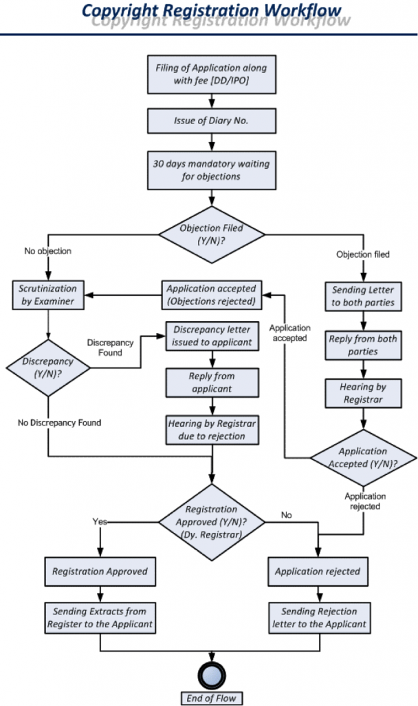](https://img.indiafilings.com/learn/wp-content/uploads/2014/10/12011447/Copright-Registration-Process-Flow.png)

All kinds of literary and artistic works can be copyrighted, you can also file a copyright application for your website or other computer programs. Computer Software or program can be registered as a ‘literary work’. As per Section 2 (o) of the Copyright Act, 1957 “literary work” includes computer programs, tables, and compilations, including computer databases. ‘Source Code’ has also to be supplied along with the application for registration of copyright for software products. Copyright protection prevents the undue proliferation of private products or works and ensures the individual owner retains significant rights over his creation.

**Patent Search**

The different types of patent searches fall into two rough categories, however: patent searching performed for legal reasons and patent searching performed for informational and design reasons.

### Patent searching as legal research

Legal patent research typically requires exhaustivity; the end goal is to produce a set of all relevant patent literature and then determine the scope of legal coverage via analysis of the claims, terms of protection, and other details. Below are some of the common patent searches performed to determine legal rights.

#### Patentability

The goal of a patentability search is to find all prior art that might be relevant to a potentially patentable invention. The patent applicant (or patent attorney or agent) then analyzes this prior art to determine if they can create a patent application that will meet the requirements of novelty and non-obviousness. Patentability searches should cover granted patents and patent applications from all possible patent offices.

#### Freedom to operate

Freedom to operate searches help determine whether an inventor can produce and market an invention in a specific territory without fear of infringement. Some inventors may initially intend to patent their inventions and, during the course of a patentability search, discover that their invention is fully anticipated by prior art and likely unpatentable. Freedom to operate searches take patentability out of the equation and focus instead on avoiding infringement. This involves asking questions surrounding the status of disqualifying prior art, for instance:

* "Are there relevant patents in the specific country or region in which I want to market my invention?”
* “Are the relevant patents still in effect, or have they expired?”
* “Was a patent ever granted for this invention, or does the disqualifying prior art appear only in applications for patents that were never granted?”

#### Validity/invalidity

Validity/invalidity searches establish whether a patent or one or more of the patent’s claims has been granted in error. The searcher attempts to find prior art that was not acknowledged during the patent process to disqualify the granted patent. An inventor might do this to establish freedom to operate or to respond to an infringement suit brought by the owner of the patent.

### 

#### Keyword searching first, classification second

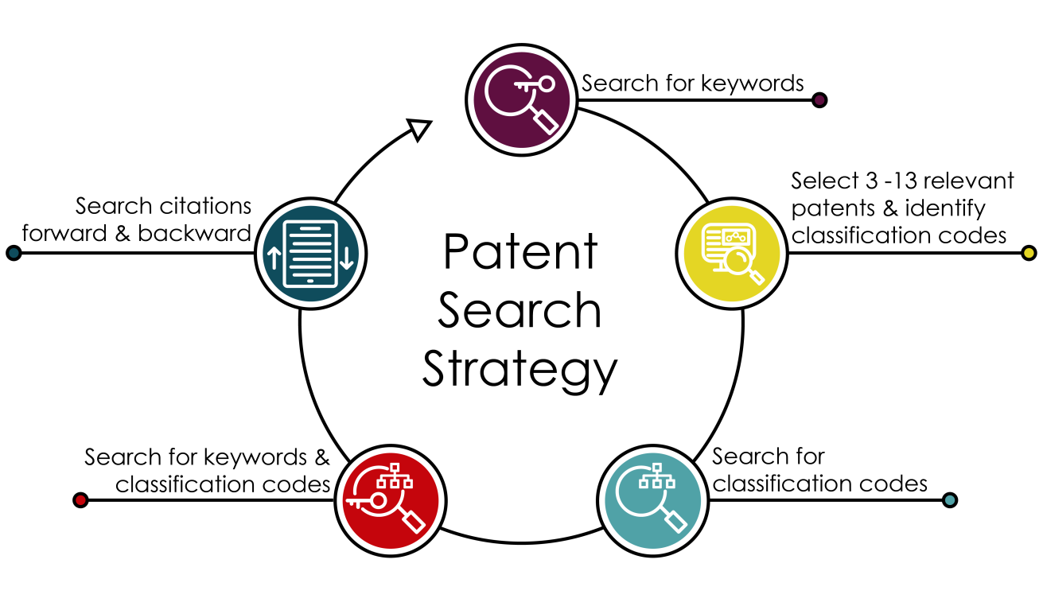

*Five step patent search strategy, adapted from Dominic DeMarco, 2010: Mechanical Patent Searching: A Moving Target*

**Patent Search process**

The first part of this section explains some basic components you can use in a search strategy. This is followed by some combined search strategies that make use of these components.

### Keywords

Most patent databases allow for keyword searching, although the scope, abilities, and quirks of these searches vary widely.

Regarding titles of patents, patent applicants may not use intuitive language, colloquialisms, and brand names in either their titles or descriptions. For keyword searching, instead consider the following:

* What does the invention do?
* If it’s an innovation upon existing technology, what’s novel about the approach?
* Is it a process, or is it a product?
* What is it made of?
* How is it used?
* What are some synonyms for it or other words that describe its nature?

Due to differing terminologies, different database coverages, and other factors, even expert keyword searchers will likely miss patents relevant to their search unless they follow up with additional strategies.

### Inventors and assignees

One productive way to begin a search is to identify a given researcher with expertise in a type of technology, or to identify the maker of a product that closely resembles what you intend to design or patent, and to search for either the inventor name or applicant, assignee, or owner name in the appropriate field.

For some historical searches, this might be the only step required to identify the desired patent(s). For other searches, this may lead to terminology for keyword searches, cited references to explore, and classification codes to expand your search.

### Forward and backward citation mining

Once you have discovered at least one relevant granted patent or patent application, you can expand your search using citations to other patent literature. Most patent searching databases include hyperlinks to patents referenced in the patent application or granted patent Many patent databases, including Lens.org, Google Patents, and Espacenet, also link from patent documents to later patent applications and granted patents that referenced them as prior art.

### Classification searching

Patent examiners assign classification codes to patent documents so that similar inventions are grouped together even if the inventors used different terminology when filing their applications.

Cooperative Patent Classification (CPC) is a single system used by the U.S. Patent and Trademark Office and the European Patent Office (EPO) to classify patents and is compatible with the International Patent Classification system used more broadly. Examiners typically assign multiple CPC codes to a single patent.

**Copyright Notice**

A **copyright notice** is a short line of text that lets the public know that your work is protected by copyright law and **is not to be copied**. These copyright notices are widely used and can be found all over, from websites and blogs, to films and music.

Each copyright notice should include **4 main components**:

1. A copyright symbol, or word
2. A date
3. An author's name, and
4. A statement of rights

A statement of rights is not a requirement. By default, a copyright notice will work to reserve all of your rights, so stating something like "All Rights Reserved" isn't technically necessary.

However, it is commonly seen this way and clarity of your rights can't hurt.

### Copyright Symbol

The universally accepted **symbol for a copyright** is the letter C in a circle: ©

You can also use the word "**copyright**."

This symbol or word should be placed at the beginning of your copyright notice:

There are **3 main types of rights** most copyright notices will maintain:

1. **All Rights Reserved**. You keep all rights to your material.

This is by far the most commonly used and seen statement of rights in copyrighted materials.

1. **Some Rights Reserved**. Seen in Creative Commons licensing.

You may allow use of your materials under certain circumstances, like only with full attribute to you, and no alteration can be done to your original material.

Stock photos are a common example of this reservation of rights.

1. **No Rights Reserved**. Sometimes you'll want to declare ownership of something, but not make that restrictive for the rest of the world.

**Patent Law in India**

A patent is an exclusive right granted by the Government to the inventor to exclude others to use, make and sell an invention is a specific period of time. A patent is also available for improvement in their previous Invention.

Foundation of Patent Law in India

The first step of the patent in India was Act VI of 1856. The main objective of the legislation was to encourage the respective inventions of new and useful manufactures and to induce inventors to reveal their inventions and make available for public. The Act was repealed by Act IX of 1857 as it had been enacted without the approval of the British Crown. Fresh legislation was enacted for granting ‘exclusive privileges’ was introduced in 1859 as Act XV of 1859. This legislation undergoes specific modifications of the previous legislation, namely, grant of exclusive privileges to useful inventions only, an extension of priority period from 6 months to 12 months. The Act excluded importers from the definition of an inventor. The Act was then amended in 1872, 1883 and 1888.

The Indian Patent and Design Act, 1911 repealed all previous acts. The Patents Act 1970, along with the Patent Rules 1972, came into force on 20 April 1972, replacing the Indian Patent and Design Act 1911. The Patent Act is basically based on the recommendations of the report Justice Ann. The Ayyangar Committee headed by Rajagopala Iyengar. One of the recommendations was the allowance of process patents in relation to inventions related to drugs, drugs, food and chemicals. Again The Patents Act, 1970 was amended by the Patents (Amendment) Act, 2005 regarding extending product patents in all areas of technology including food, medicine, chemicals and microorganisms. Following the amendment, provisions relating to exclusive marketing rights (EMR) have been repealed, and a provision has been introduced to enable the grant of compulsory licenses. Provisions related to pre-grant and anti-post protests have also been introduced.

**Patent Law**

Under this act, rights are granted for inventions covering a new and inventive process, product or an article of manufacture that are able to satisfy the patent eligibility requirements of having novelty, inventive steps, and are capable of industrial application.

# Rights and obligations of the patentee

## Rights of Patentee

* Right to exploit patent: A patentee has the exclusive right to make use, exercise, sell or distribute the patented article or substance in India, or to use or exercise the method or process if the patent is for a person. This right can be exercised either by the patentee himself or by his agent or licensees. The patentee’s rights are exercisable only during the term of the patent.
* Right to grant license: The patentee has the discretion to transfer rights or grant licenses or enter into some other arrangement for a consideration. A license or an assignment must be in writing and registered with the Controller of Patents, for it to be legitimate and valid. The document assigning a patent is not admitted as evidence of title of any person to a patent unless registered and this is applicable to assignee not to the assignor.
* Right to Surrender: A patentee has the right to surrender his patent, but before accepting the offer of surrender, a notice of surrender is given to persons whose name is entered in the register as having an interest in the patent and their objections, if any, considered. The application for surrender is also published in the Official Gazette to enable interested persons to oppose.
* Right to sue for infringement: The patentee has a right to institute proceedings for infringement of the patent in a District Court having jurisdiction to try the suit.

## Obligations of patentee

* Government use of patents: A patented invention may be used or even acquired by the Government, for its use only; it is to be understood that the Government may also restrict or prohibit the usage of the patent under specific circumstances. In case of a patent in respect of any medicine or drug, it may be imported by the Government for its own use or for distribution in any dispensary, hospital or other medical institution run by or on behalf of the Government. The aforesaid use can be made without the consent of the patentee or payment of any royalties. Apart from this, the Government may also sell the article manufactured by patented process on royalties or may also require a patent on paying suitable compensation.
* Compulsory licenses: If the patent is not worked satisfactorily to meet the reasonable requirements of the public, at a reasonable price, the Controller may grant compulsory licenses to any applicant to work the patent. A compulsory license is a provision under the Indian Patent Act which grants power to the Government to mandate a generic drug maker to manufacture inexpensive medicine in public interest even as a patent in the product is valid. Compulsory licenses may also be obtained in respect of related patents where one patent cannot be worked without using the related patent.
* Revocation of patent: A patent may be revoked in cases where there has been no work or unsatisfactory result to the demand of the public in respect of the patented invention.
* Invention for defence purposes: Such patents may be subject to certain secrecy provisions, i.e. publication of the Invention may be restricted or prohibited by directions of Controller. Upon continuance of such order or prohibition of publication or communication of patented Invention, the application is debarred for using it, and the Central Government might use it on payment of royalties to the applicant.
* Restored Patents: Once lapsed, a patent may be restored, provided that few limitations are imposed on the right of the patentee. When the infringement was made between the period of the date of infringement and the date of the advertisement of the application for reinstatement, the patent has no authority to take action for infringement.